Application Programming Interface

& Interface Control Document

Collaboration between: MSD P21311 and NXT

The two systems to communicate between shall be referred to as “The Headset” and “The Wheelchair”. This is incorrect from a literal standpoint, but the hardware to be used is still undecided.

Wheelchair opens connection, waiting for peripheral devices such as the headset

ICD Characteristics to use based on Application Intentions

Physical Medium to communicate over:

* Ethernet

Data Structure:

* Command with arguments
* 1 Command per action

Potential Programming Languages and Pertinent Libraries

C and/or python

Allow for Multi-language support

zero-MQ vs active-MQ

Application Level Protocol: all data to be passed using JSON key-value pairs

* Both systems will have an agreed upon list of known locations to select from. When the user chooses one of these locations, the headset will send that location (a unique, alphanumeric string) to the wheelchair.
* Wheelchair operates in a series of states:
  1. IDLE until device connected
  2. Remain STOPPED until location received
  3. Begin MOVING when destination received
     + While moving, if ***stop*** command received, halt motors, wheelchair ***ack*** to headset once stopped.
       - A new destination could be selected in this state. Expect either a ***start*** command or the name of the new destination.
     + Add ***left / right*** vector commands for the sake of troubleshooting
  4. FINISHED if the destination is reached, ***ack*** sent to headset once achieved.

Questions from Cheyenne:

1. What are you looking for/expecting from the **ack** messages from the chair to the headset?
2. Do you know the full format of the message being sent? Or is it simply done with ZeroMQ (assuming headset side is using python?) with something along the lines of:

socket = context.socket(zmq.REQ)

socket.connect("tcp://127.0.0.1:5000")

socket.send_json(data)

1. You wanted to use a PAIR socket connection correct?
2. How do you want the locations list?

|  |  |
| --- | --- |
|  | 0 Aero Lab |
|  | 1 Engineering Hall |
|  | 2 Thermal Analysis Lab |
|  | 3 Student Services |
|  | 4 MechE Corner |
|  | 5 MechE Office |
|  | 6 2149 |
|  | 7 Thermal Hall Connection |
|  | 8 Dr Du's office |
|  | 9 Gordon Atrium |
|  | 10 Xerox |
|  | 11 Women In Engineering |
|  | 12 Atrium Center |

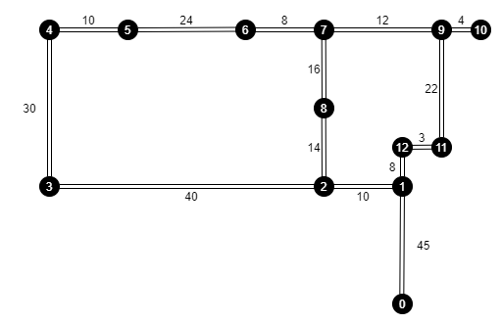

RIT Second Floor Gleason Blueprints: [J:\Design & Construction\Web Dwgs\Bldgs strippt\009-stripped\009-2stripped Layout1 (1) (rit.edu)](https://www.rit.edu/fa/facilities/system/files/floorplans/1/009-2.pdf)

~~{~~

~~“Wheelchair update”: {~~

~~“State”: “STOPPED/MOVING”,~~

~~“Reason”: “Destination reached/user initiated”~~

~~}~~

~~}~~